ROYAL ROAD ELEMENTARY SCHOOL
Classroom Materials for Grade 1 French Immersion, 2023-2024
*When we request brands, it is because of quality.
*Please put your child’s name on the items with a star.

- 2 packages (12) sharpened pencils (Please no Dollar Store brand.)
- 3 erasers (white)
- 3 Glue sticks (large size)
- 2 Hilroy Exercise books — pages are plain at the top and lined on the bottom (Yellow, 72 pages, 23.1cm x 18cm) *See picture below.
- duotangs (2 blue, 2 orange, 2 green, 1 red)
- 4-6 large EXPO dry-erase markers
- 1 box large Ziploc bags
- 2 Boxes of tissues
- 1 bottle of white liquid school glue
- 1 Package Crayola crayons (24)
- 1 Package Crayola pencil crayons (24)
- 1 Pack Crayola markers (no fine tips)
- 1 twin pocket duotang * See picture below.
- 1 scrapbook (Dollarama)
- Scissors — good quality (Please re-use last year’s if possible.)
- 1 message bag- Dollarama (Neoprene laptop ones last longer. *see picture below)
- 2 containers of modelling clay (ex: Play Doh)
- Lunch bag
- Refillable water bottle
- Indoor sneakers (laces only if they can tie)
- "Roomy" book bag (it needs to hold snow pants, lunch bag, communication bag)
- Full change of clothing, labelled in a Ziploc bag.
--------------------------------------------------------------------------------------------------------------------------$35 School fee (Can be paid in School Cash Online or by sending cash or cheque payable to
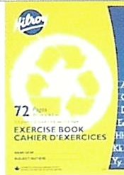
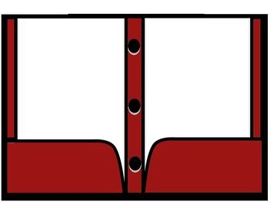
Royal Road School).
