Royal Road Elementary School
Classroom Materials for Grade 2 French Immersion 2023-2024
1 Communication bag (available at Dollarama. Please see picture below.
1 Pencil Case
2 Small Hilroy project books (pages are half plain/half lined – yellow cover)
5 Duo-tangs (not the pocket folder duo-tangs) 1 blue, 1 yellow, 1 red, 1 green, 1 orange
4 Hilroy Exercise books (32 pages – no coils)
3 White Erasers – Staedtler erase best
2 Packs of 12 Sharpened pencils (steadtler brand if possible)
1 Package of Crayola colouring pencils
1 Package of Crayola markers (thick)
1 Package of Crayola wax crayons
3 Large Glue Sticks (Net WT 40 gm)
1 White Elmer’s school glue
2 Containers of Play Doh
1 Pair of good quality Steel Blade Scissors
1 Fine point Sharpie (Black)
2 Boxes of Kleenex
10 Dry erase markers (Expo, Bic or Crayola)
1 Box of large Ziploc bags
1 Pencil Sharpener
$35 School fee (School Cash Online - cheque payable to Royal Road Elementary or cash)
1 Water bottle
INDOOR SHOES (sneakers – non marking soles) Full change of clothing (labeled) in a Ziploc bag

**Please do not label your child’s supplies.
There may be specific items requested by your child’s homeroom teacher in September.
Thank you very much for your cooperation in this matter.
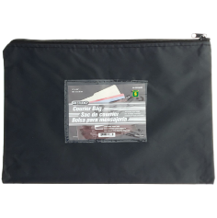
Grade 2 French Immersion Teachers

