Grade 3 French Immersion – Royal Road Elementary School
Classroom Materials 2023-2024
Specific brands are requested because of quality. This list of supplies is adequate for the entire school year, however if your child does not use proper care of supplies, extra may be required.

1 communication bag (available at Dollarama. See picture below.)
1 pair of headphones (no earbuds)
1 pencil case (for markers)
1 small Hilroy project books (pages are half plain/half lined – yellow cover)
10 duo-tangs – 2 blue, 2 yellow, 2 red, 1 green, 1 purple, 1 orange (not the pocket folder duo-tangs)
4 Hilroy exercise books (32 pages – no coils)
1 Sketch book 9”x12” (Dollarama – black with coils)
36 Staedtler sharpened pencils (last longer & sharpen well)
6 Staedtler white erasers (erase the best)
2 pencil sharpeners
2 fine tip Sharpies
1 pkg of Crayola colouring pencils
1 pkg of Crayola markers (thick)
1 pkg of Crayola Super Tips markers (see picture below)
1 pkg of multi-coloured highlighters (yellow, pink, blue, green, orange)
2 large Elmer’s glue sticks
1 pair of good quality steel blade scissors
1 ruler
10 dry-erase markers (Expo, Quartlet or Crayola work best) – used multiple times daily
1 whiteboard eraser
1 pkg lined paper
1 box of Kleenex
1 box of large Ziploc bags
1 box of small/medium Ziploc bags
1 water bottle
Indoor sneakers appropriate for Physical Education (no black soles)
$35 School fee (Can be paid on School Cash Online or by cheque made out to Royal Road Elementary or cash)

**Please place all school supplies in a XL Ziploc bag labelled with your child’s name. Supplies that will not be used right away (extra erasers, dry-erase markers, pencils, duo-tangs, etc) will be kept in this bag and stored in the classroom for easy access. No need to label items! XL Ziplock bags will seal and ensure your child’s items don’t fall out.
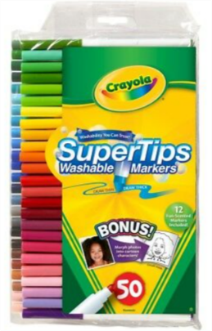
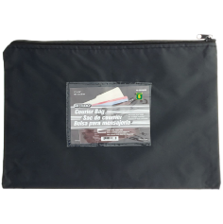
Thank you very much for your cooperation in this matter.
